______________’s Design Journal
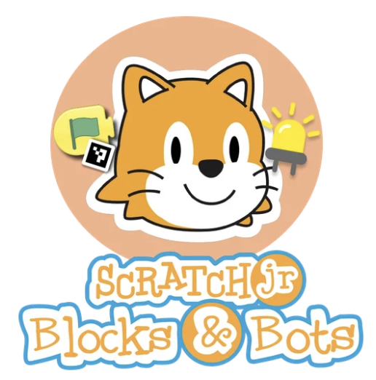
Name:__________________________ Date:_____________
Lesson 5:
How would you make ScratchJr blocks off-screen?
What size would they be? What materials would you use? How many would you make?

Draw your ideas here:

Or here:


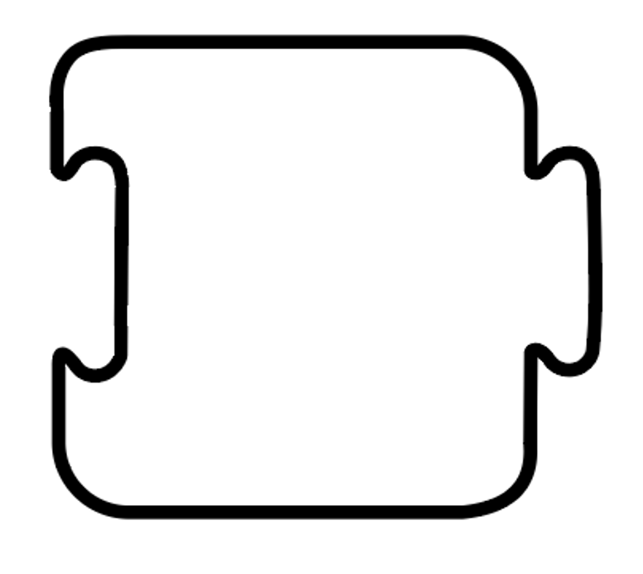






Name:_____________________ Date:_____________

Lesson 12:
Write or draw your sentence here:
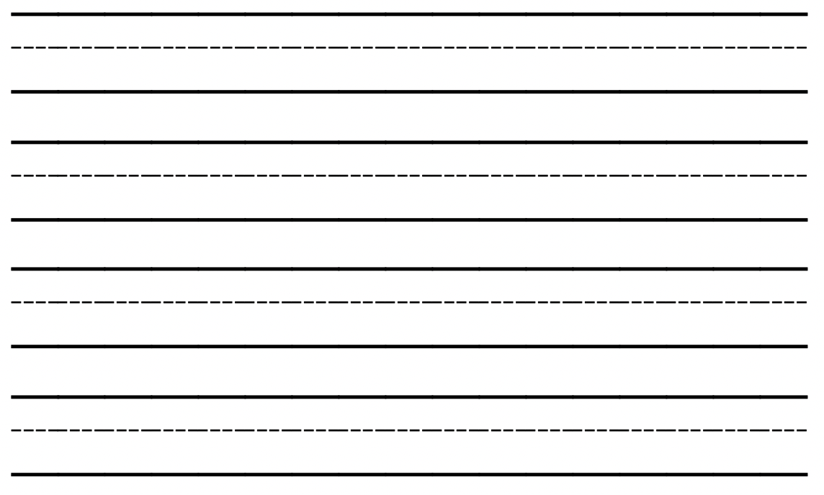


Name:________________________ Date:_____________

Lesson 14:
How did you imagine your robot?
Draw it here:

Name:______________________ Date:_____________

Lesson 15:
What are the circuit components? How would you use them? What is safe?
Take notes here:
Components | Notes
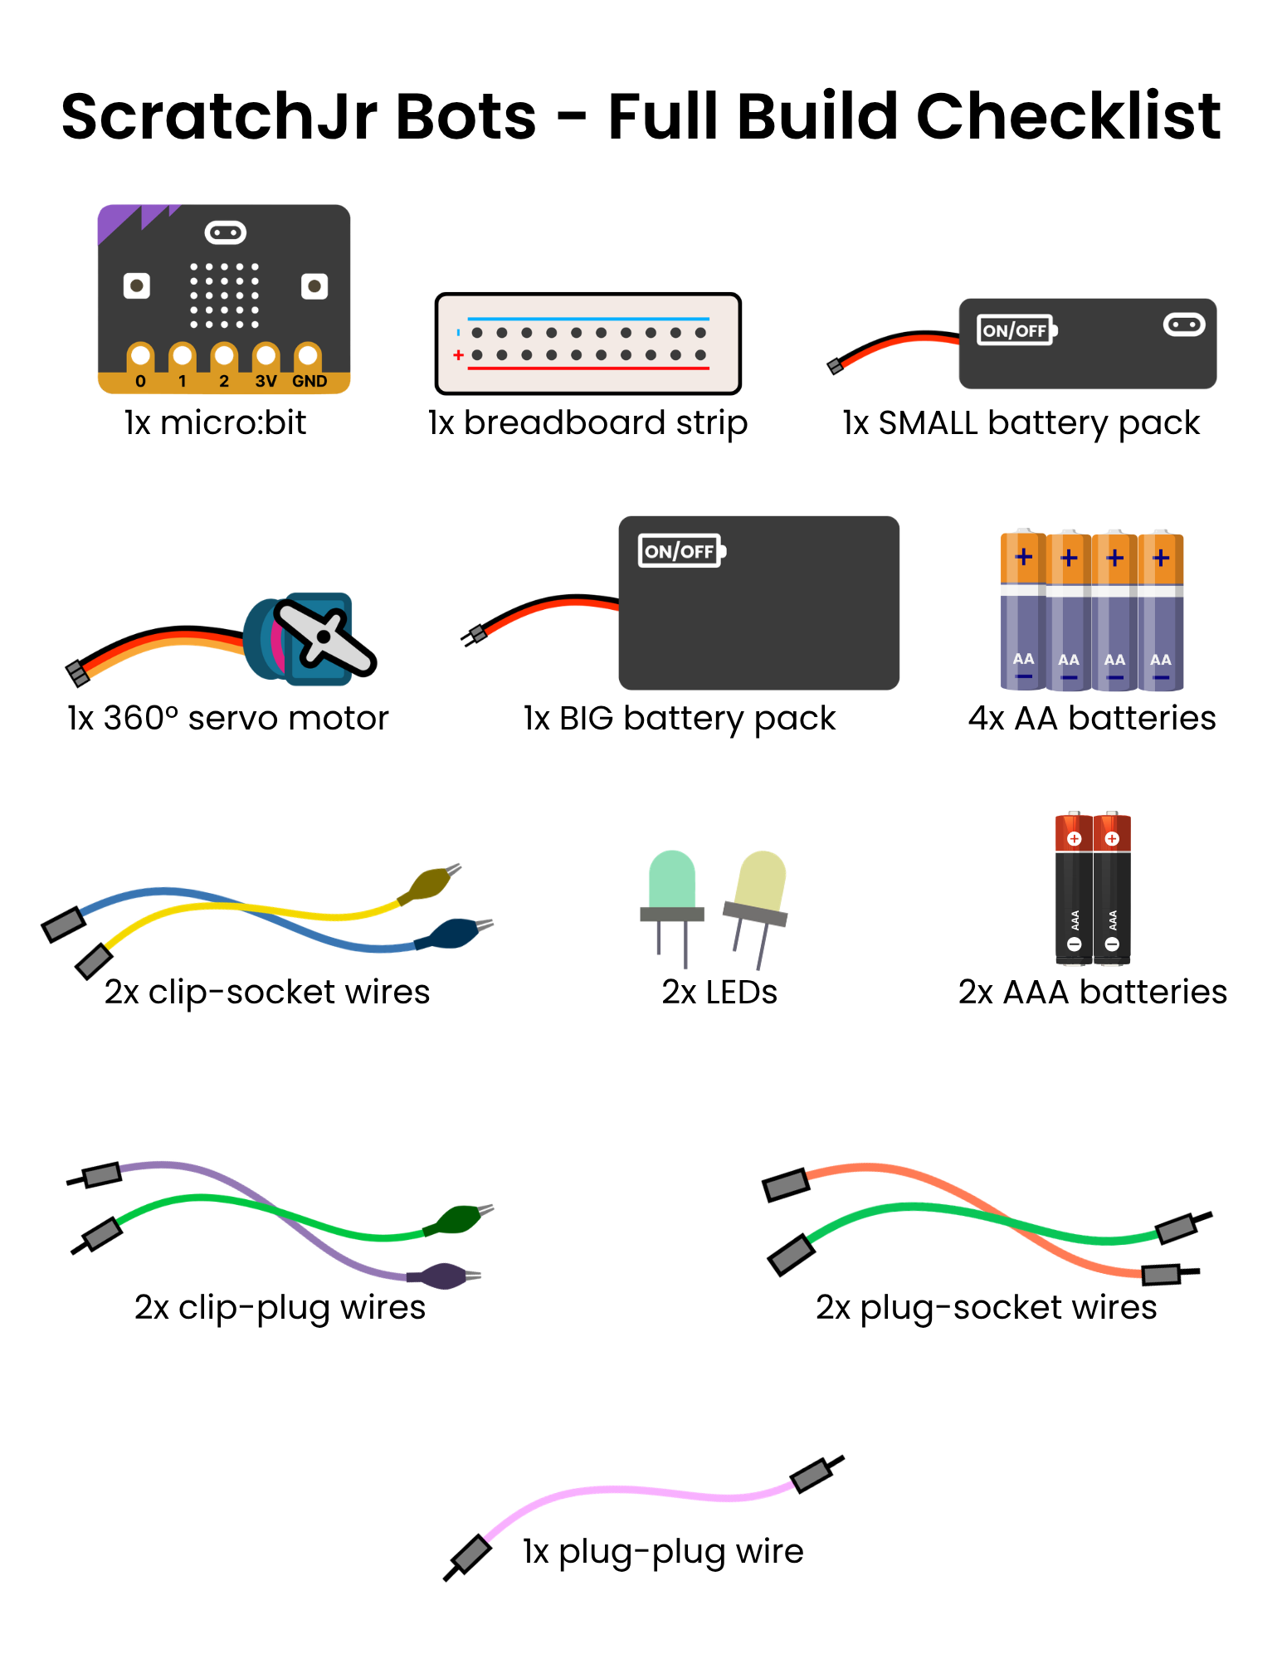
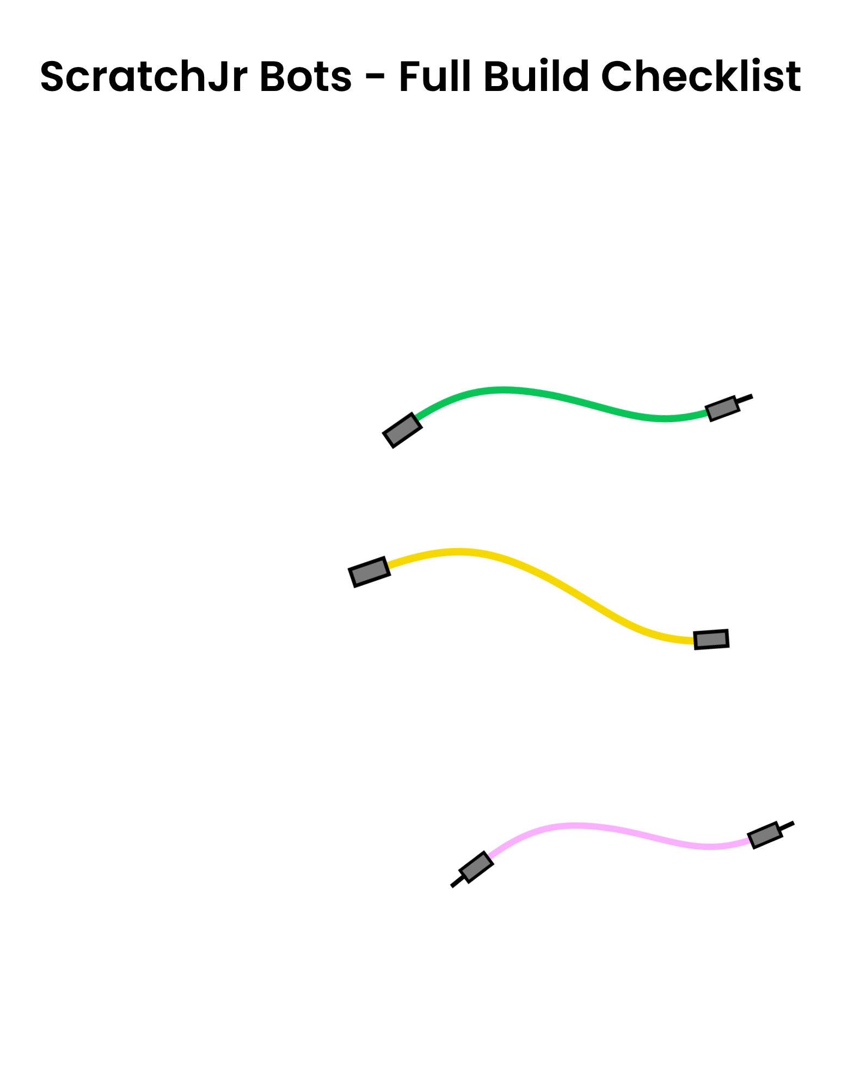
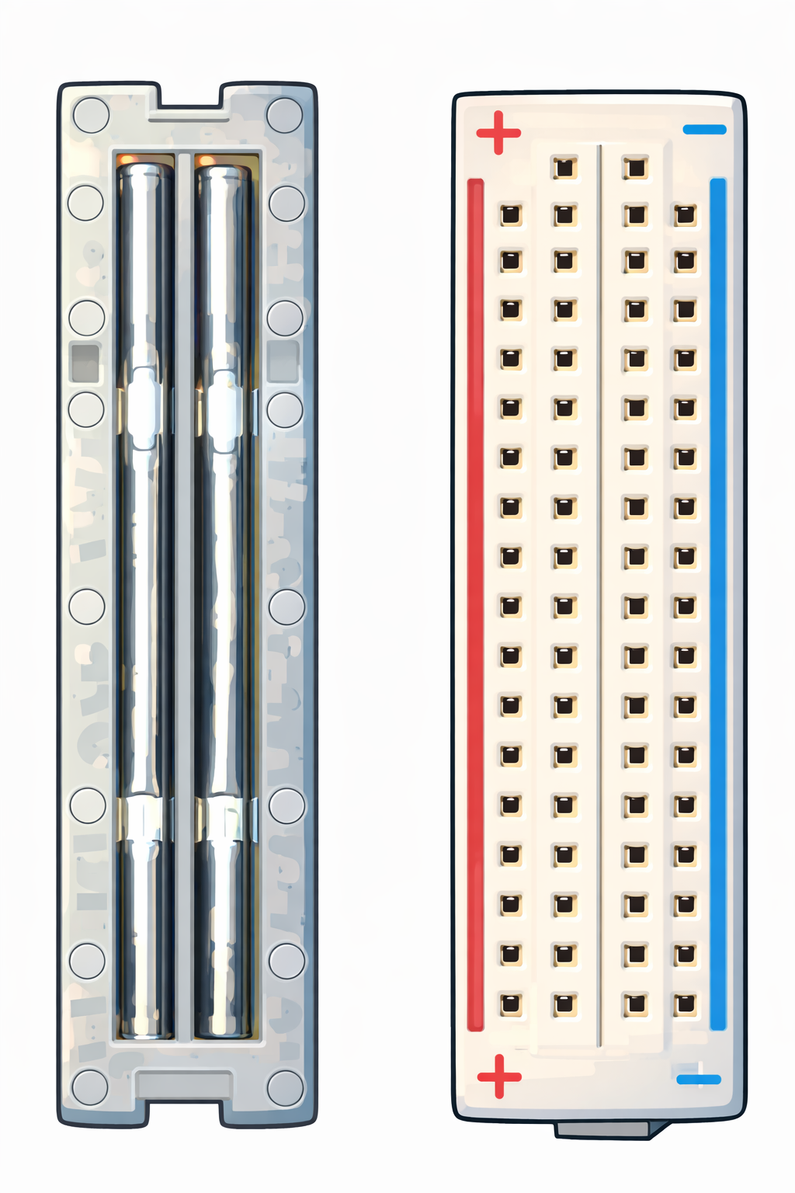
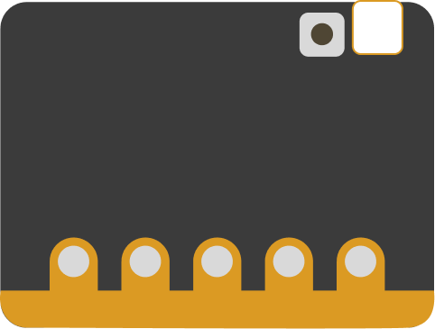

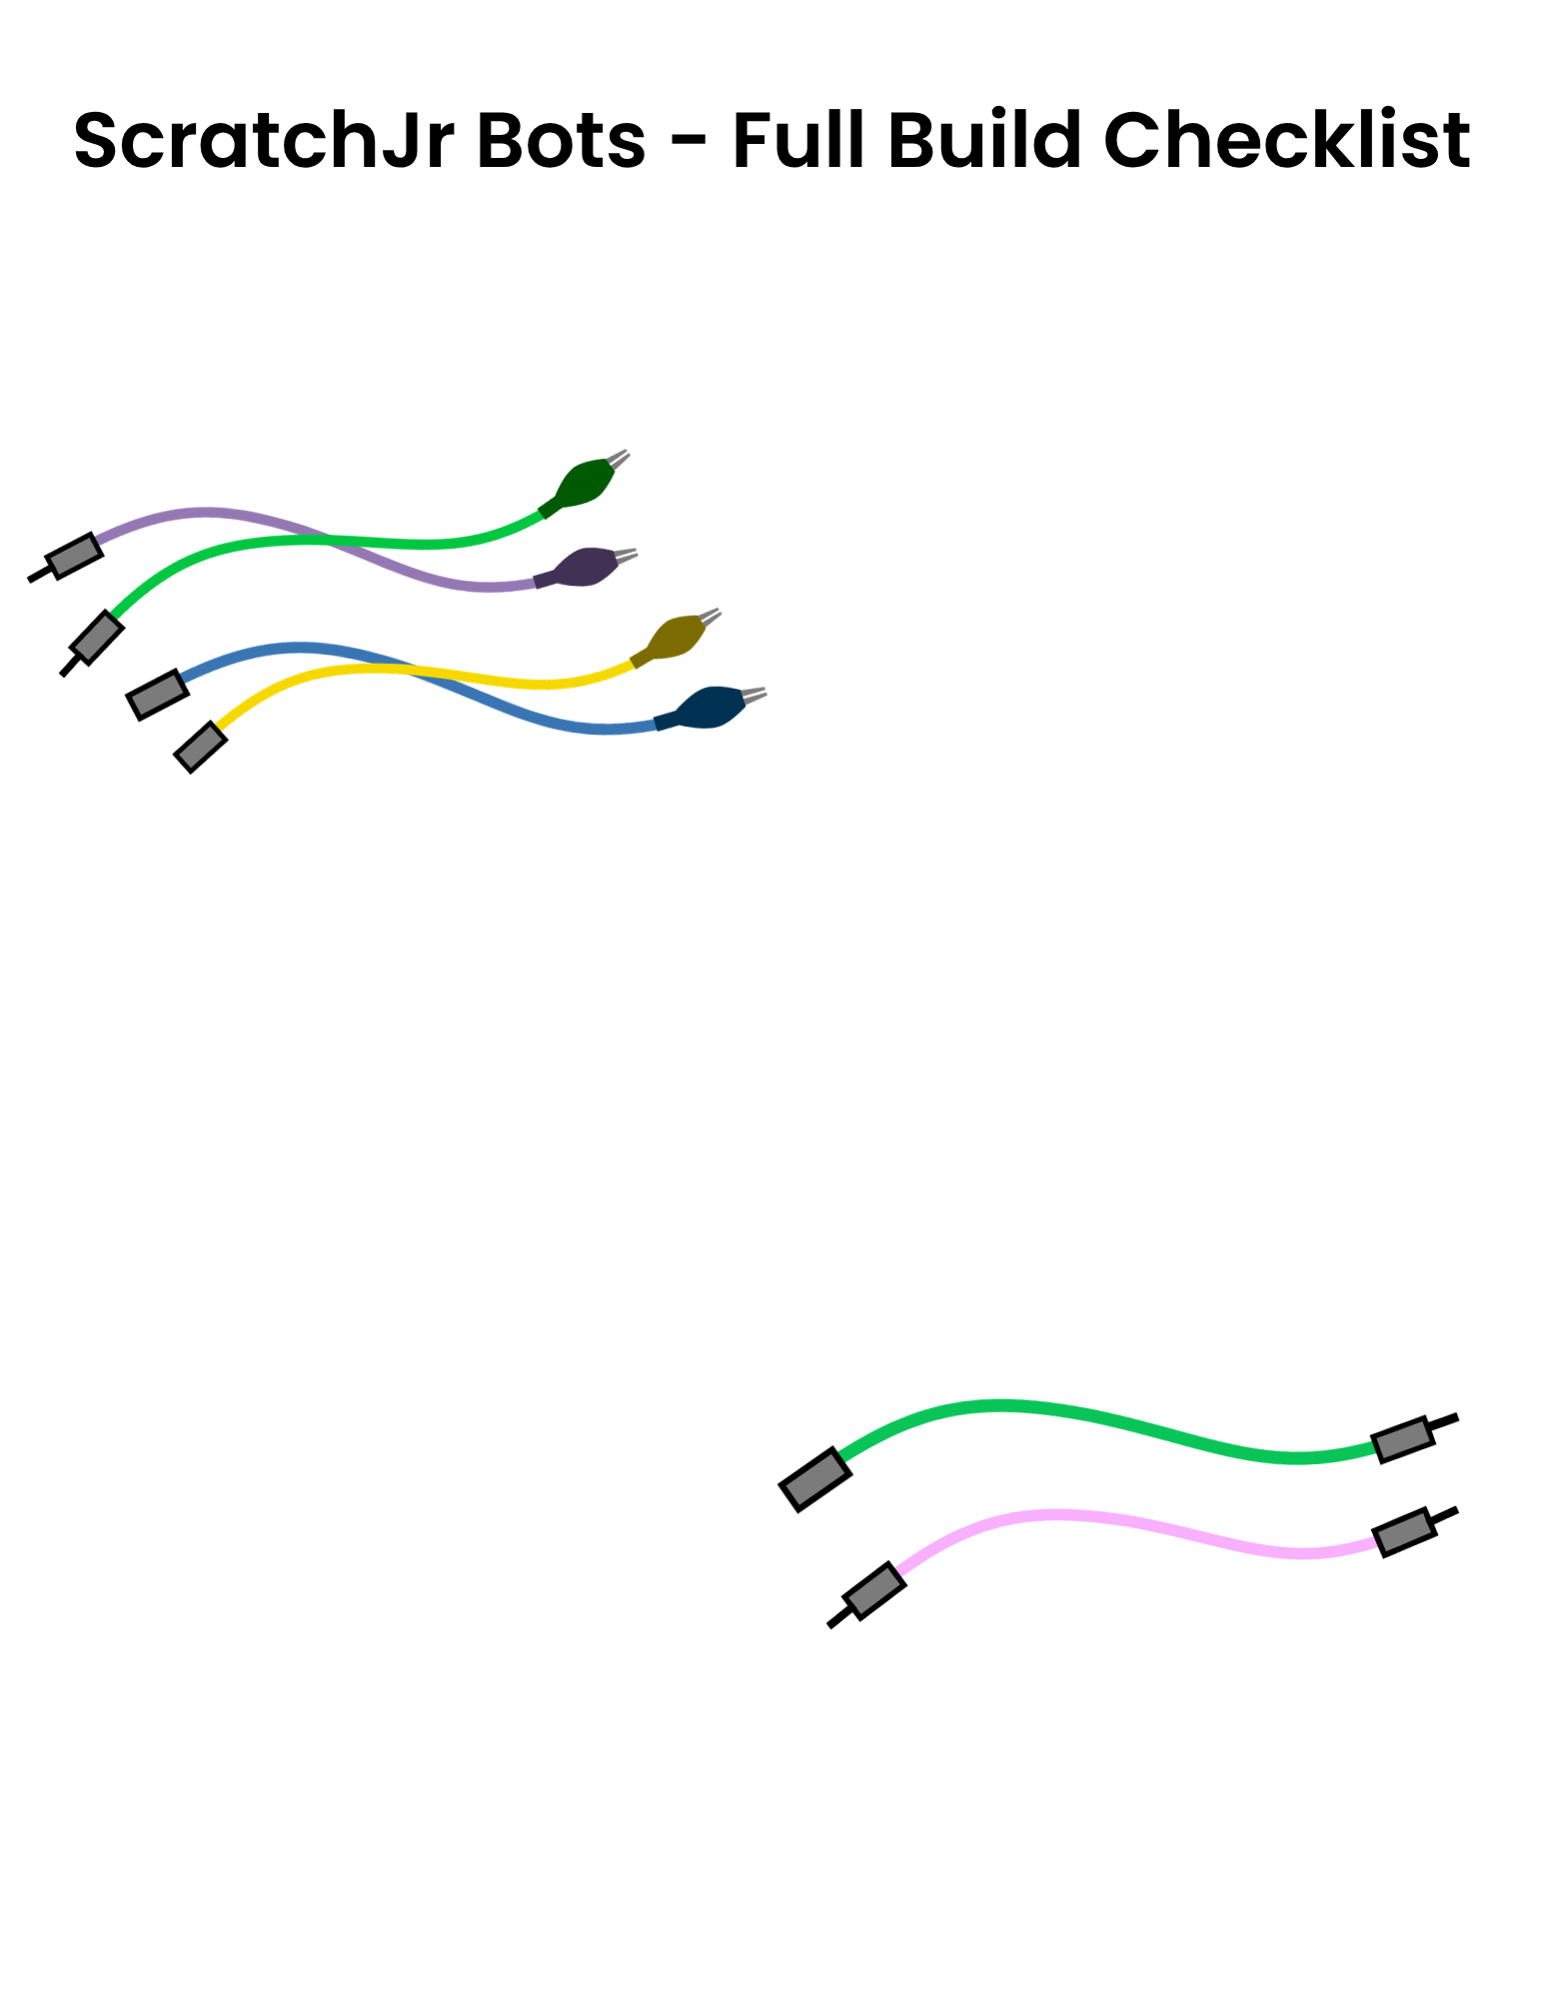



Name:_________________________ Date:_____________

Lesson 20:
Think and draw what you would like your robot to become
Plan your robot’s body design here:

Name:________________________ Date:_____________

Lesson 24:
Think and draw how you would like to adjust your robot
Plan your robot’s body design here:

Name:________________________ Date:_____________

Lesson 29:
Considering the story sequence of events
Plan your background here:

Name:_________________________ Date:__________________

Lesson 30:
Considering the materials, circuit outputs, and the story
Plan your character here:

Name:________________________ Date:_____________
Lesson 32:
Considering your character and the story scenes


Plan your program here:










Name:________________________ Date:_____________
Lesson 35:
My Collaboration Web
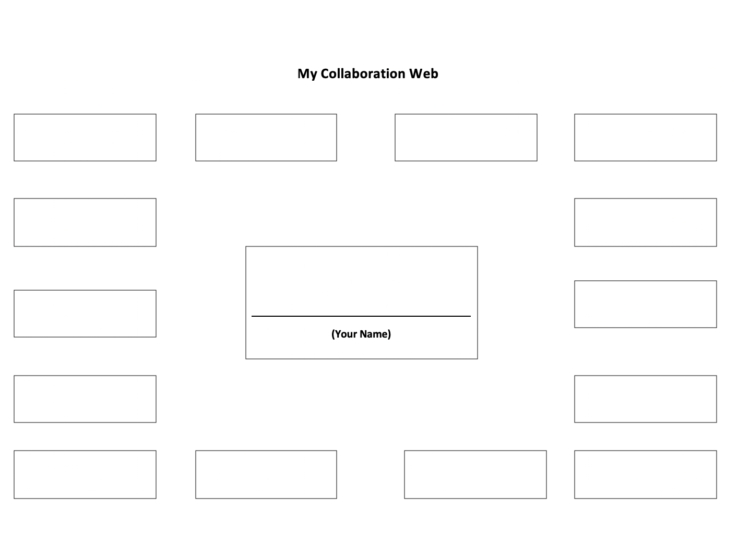
First, write your name in the center rectangle. Next, fill the other rectangles with the names of the classmates who helped you with your projects. Then, draw a line from your rectangle to each classmate’s rectangle every time that person helped you. When you finish, you’ll have a map that will make it easier to write your thank‑you card.
Name:________________________ Date:_____________

Lesson 35:
Identify two people who helped you the most
Write their names here:

- 

- 

Then, write them a thank-you card:
Dear ______________________,


Thank you for



From_________________________

Dear ______________________,


Thank you for



From_________________________

